**Random Access Memory(RAM):**

After magnetic hard drive or SSD, RAM is the biggest piece of memory which exists on the computer hardware. RAM is used to store the programs and data being used by the CPU in real time. The data on the random access memory can be read, written, and erased any number of times.

It is a volatile memory which means the data stored in the RAM evaporates the moment you cut the power. That’s one of the reasons random access memory can’t be used as a permanent storage despite the fact that it’s way faster than the traditional magnetic disk-based hard drives.

**Types of RAM:**

* Static RAM.
* Dynamic RAM.

***SRAM (Static RAM):*** It stores a bit of data using the state of a six transistor memory cell. SRAM is way faster than DRAM, but costlier.

***DRAM (Dynamic RAM):*** It stores a bit data using a pair of transistor and capacitor which constitute a DRAM memory cell.

**Read-Only Memory(ROM):**

Another notable memory type present on the computer is the ROM. As the name suggests, the data on the memory can only be read by the computer. So, what’s the reason these read-only memory chips are in use when we have the RAM chips?

The ROM is a non-volatile memory, it doesn’t forget the data even if the power supply is removed. ROM is used to store firmware for the hardware which hardly gets any regular updates, for instance, the BIOS.

The data on the traditional form of ROM is hard wired to it i.e written at the time of manufacturing. Over time, the read-only memory has been developed to support erasing and rewriting of data, although, it can’t achieve the efficiency level of a random access memory.

**Types of ROM:**

* Mask ROM.
* PROM.
* EPROM.
* EEPROM.

**Mask ROM:** This is the type of ROM for which the data is written during the manufacturing of the memory chip.

**PROM (Programmable Read-only Memory):** The data is written after the memory chip has been created. It is non-volatile.

**EPROM (Erasable Programmable Read-only Memory):** The data on this non-volatile memory chip can be erased by exposing it to high-intensity UV light.

**EEPROM (Electrically Erasable Programmable Read-only Memory):** The data on this non-volatile memory chip can be electrically erased using field electron emission (Fowler–Nordheim tunneling). Modern EEPROMs are quite efficient in terms of the read-write capabilities.

The above-mentioned types were the semiconductor-based ROMs. Optical Storage media like CD-ROM is also a form of read-only memory.

II. Why not use an OS?

There are many reasons you might not want to use an operating system.

**Simplicity**

An operating system is a complicated piece of software containing a lot of components that may be unnecessary for what the user aims to do.

**Performance**

When you run an application on an OS, there are lots of things going on in the background that require processing power. Speed and memory are both heavily affected by the OS.

**Reliability (as a consequence of simplicity)**

Since there are many things happening at once on an OS, there is more opportunity for things to go wrong.

**Security**

Security is another important reason, as you’ll see in this next example

**STARTUP/TURNING ON A COMPUTER**There's an initial instruction pointer in your computer that is set to location 0xFFFF0 (220 -16) in RAM. That location is part of a portion in physical RAM that simply redirects you to a region of ROM (better idea → nonvolatile memory) containing instructions hardwired by the manufacturer to do whatever we want them to.

A more modern solution is to store some information in EEPROM that will tell the computer what to do when it starts up. First, we need to store the location and size of the program on the hard disk (the manufacturer hard codes these constants). Second, we’ll need a program that loads and executes the word count program (it can do this by taking the word count program from the disk and putting it into RAM). **The file is stored in a contiguous array of sectors on the disk drive. (Save the word count program on the disk because EEPROM has limited memory).**

**Bootstrapping** is the process of loading software into the memory of a computer after the computer has been powered on. In this case, the word count program must be loaded into RAM so that it can be executed after the computer is started.

This is done by the BIOS, or the basic input/output system. One of the most common uses of [Flash memory](https://computer.howstuffworks.com/flash-memory.htm) is for the **basic input/output system** of your computer, commonly known as the BIOS (pronounced "bye-ose"). On virtually every computer available, the BIOS makes sure all the other chips, hard drives, ports and CPU function together. At startup, the BIOS is used to get the computer system started. Additionally, it is also used to manage data flow between the operating system and any devices. The **BIOS is stored in EEPROM** and at startup does the following:

1. Runs hardware sanity checks and initialized the hardware
2. Searches for devices
3. Looks for Master Boot Record
4. Attempts to boot off of Master Boot Record

#### Master Boot Record

The Master Boot Record (MBR) is the information in the first sector of any hard disk or diskette that identifies how and where an operating system is located so that it can be boot (loaded) into the computer's main storage or RAM. The Master Boot Record is also sometimes called the "partition sector" or the "master partition table" because it includes a table that locates each partition that the hard disk has been formatted into. In addition to this table, the MBR also includes a program that reads the boot sector record of the partition containing the operating system to be booted into RAM. In turn, that record contains a program that loads the rest of the operating system into RAM.

The 1st sector on the disk (hard disk), consisting of 512 bytes, is the Master Boot Record (MBR). The first part of this sector is the boot program which is run by the firmware in EEPROM. When the computer starts up, the EEPROM searches for the first device with an MBR and loads it into memory. Normally, the MBR would then read the volume boot record, VBR, into memory. However since the VBR is OS-specific and the MBR is OS-agnostic (and we do not want to use an OS), we will go straight from the MBR to the program. The MBR is structured as follows:

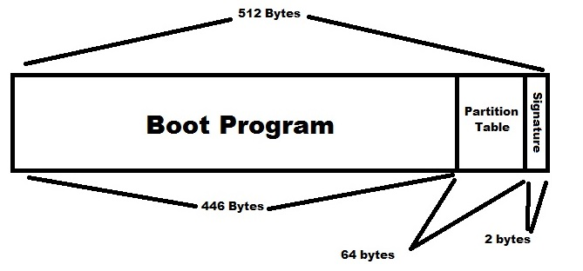

The first 446 bytes are the boot program. The next 64 bytes are a partition table. Each partition is 16 bytes long and contains information such as type and bootability, **as well as sector counts for the offset of the partition and for the size of the partition plus other info**, including a type byte and whether the partition is bootable or not. The remaining two bytes are the signature and are required to be 0x55 and 0xAA (using little endian convention -> 0xAA55). This ensures that this sector is, in fact, the Master Boot Record.

**The partition table tells information about the rest of disk by convention: it only consists of 4 entries because they assumed that nobody would ever partition their device into more than 4 parts. Partition table entries consist of Origin, Size, Sector count for offset (32 bit).**

**EEPROM copies the x86 code sector of the MBR to 0x7C00 and jumps into it.**

The firmware boots by reading the MBR & executing the code in the MBR. The MBR examines the partition table and finds a partition that's bootable, then boots that partition. This process is called **chain loading.**

**Chain-loading**: firmware -> MBR (OS-agnostic) -> VBR (OS-specific) -> kernel (many sectors) -> your apps



**Reading data from the disk**

At this point, it’s clear that we need some sort of subroutine for reading data from the disk. The firmware, MBR and word count program will all be able to use it.

The controller communicates through the buses via their registers, listed below:



Reading 0x01000000 (0xC0) from the status and command register indicates that the disk is ready to receive a command. As the C library does not have built in functions for x86 I/O, we'll declare one and pretend the rest exist and are implemented.





#### Code Implementation

To summarize, the load sequence that we want is: **Firmware** (permanent software programmed into ROM) → MBR → word count program. In order to implement this, we will need a subroutine that allows us to read data from the disk. The following subroutine requires the sector number to read from and the memory address to read into.

Note: There are no error checks in this code (assumed that there are no I/O or parity errors). Due to this, read_ide_sector can return void.

The **disk controller** is the controller circuit which enables the CPU to communicate with a hard disk, floppy disk or other kind of disk drive. In computer architecture, a **bus** is a communication system that transfers data between components inside a computer, or between computers.

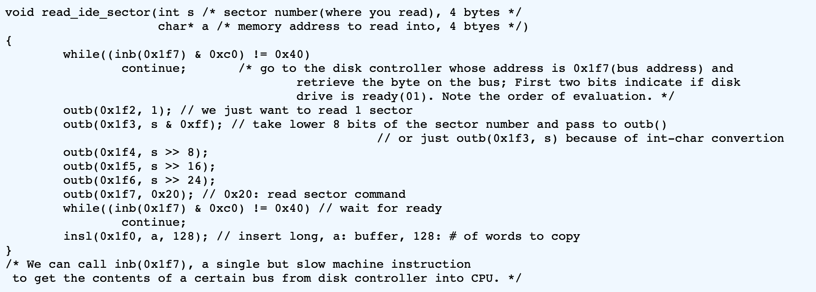



128 -> 512/sizeof(int): Moves 512 bytes to RAM.

Additionally, we must implement a routine that allows us to print the result to the display screen. This function takes in the number of words as parameter.

void output_to_screen(long n){

short *p = (short*)0xb8000 + 80*25/2 - 80/2;

do{

// make sure that the digits print in the correct order

*--p = (0x700)| (n % 10 + '0');

n /= 10;

} while (n != 0);

}

Finally, we must use the halt instruction once the program is finished.

void done(long nwords){

output_to_screen(nwords);

halt();

}

Now, using all of the subroutines, we can put together our main function.

void main(void){

long nwords = 0; // number of words

bool inword = 0; // are we in the middle of a word?

int s = 1000;

char buf[512];

for (;;){

read_ide_sector(s++, buf); // read the sector into the buffer

for (int ix = 0; ix < sizeof(buf); ix++){

// assume a null byte indicates the end of the file

if (!buf[ix])

done(nwords);

// check if the letter is valid (a-z)

bool isletter = 'A' | 'a' <= buf[ix] && buf[ix] <= 'z' || 'z'

nwords += isletter & ~inword;

inword = isletter;

}

}

}

**Issues:**

1. Not able to tell how big the file is
2. Not able to cout word count